**Pizza Sales SQL queries**

KPI‘s

1. Total Revenue of all Pizza Orders: The sum of the total price of all pizza orders.

Select round(SUM(total_price),2) as Total_Revenue from pizza_sales

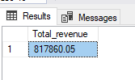

2. Average Order Value: The average amount spent per order, calculated by dividing the total revenue by the total number of orders

select SUM(total_price)/COUNT(distinct order_id) as AVG_order_values from pizza_sales

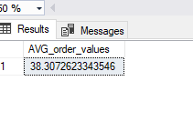

3. Total Pizza Sold: The sum of the quantities of all pizzas sold.

select sum(quantity) as Total_Pizza_sold from pizza_sales

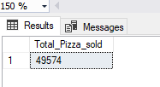

4. Total Orders: The total number of orders placed

select count(distinct order_id) as Total_orders from pizza_sales

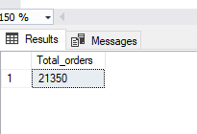

5. Average Pizzas Per Order: The average number of pizzas sold per order, calculated by dividing the total number of pizzas sold by the total number of orders.

select cast(cast(sum(quantity) as decimal(10,2)) /

cast(COUNT(distinct order_id) as decimal(10,2))as decimal(10,2)) as Average_pizza_per_order from pizza_sales

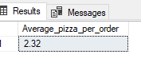

Chart Requirements

6. Hourly trend for Total pizzas sold

select DATEPART(hour,order_time) as order_hour , SUM(quantity) as Total_pizzas_sold from pizza_sales

group by DATEPART(hour,order_time)

order by order_hour asc

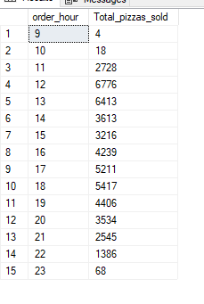

7. Weekly trend for Total orders

select DATEPART(ISO_WEEK, order_date) as Week_number , YEAR(order_date) as Order_year , count(distinct order_id) as Total_order from pizza_sales

group by DATEPART(ISO_WEEK, order_date), YEAR(order_date)

order by DATEPART(ISO_WEEK, order_date), YEAR(order_date)

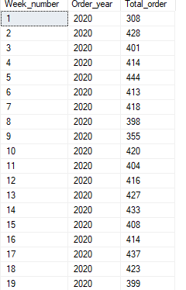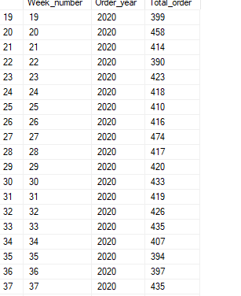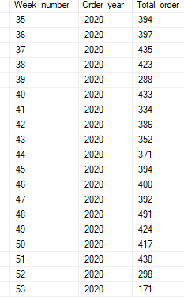

8. Percentage of sales by pizza category

select pizza_category,round(sum(total_price),2) as total_sales,round(SUM(total_price)*100/(select sum(total_price) from pizza_sales),2)as pct from pizza_sales

group by pizza_category;

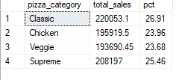

9. Percentage of sales by pizza size

select pizza_size,round(sum(total_price),2) as total_sales,round(SUM(total_price)*100/(select sum(total_price) from pizza_sales where datepart(QUARTER,order_date)=1),2)as pct from pizza_sales

where datepart(QUARTER,order_date)=1

group by pizza_size

order by pct desc

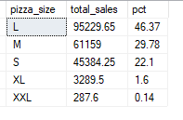

10.

a.Top 5 Best Sellers by Revenue, Total Quantity and Total Orders

select top 5 pizza_name, SUM(total_price) as Total_revenue from pizza_sales

group by pizza_name

order by Total_revenue desc

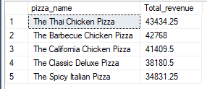

b. Bottom 5

select top 5 pizza_name, SUM(total_price) as Total_revenue from pizza_sales

group by pizza_name

order by Total_revenue Asc

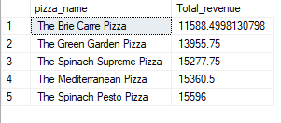

c. Top 5 by qty

select top 5 pizza_name, SUM(quantity) as Total_qty from pizza_sales

group by pizza_name

order by Total_qty Desc

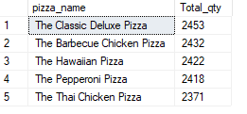

d. Bottom 5 by qty

select top 5 pizza_name, SUM(quantity) as Total_qty from pizza_sales

group by pizza_name

order by Total_qty ASC

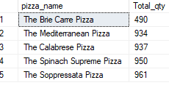

e. Top 5 by orders

select top 5 pizza_name, COUNT(distinct order_id) as Total_orders from pizza_sales

group by pizza_name

order by Total_orders Desc

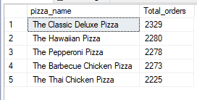

F. bottom 5 by orders

select top 5 pizza_name, COUNT(distinct order_id) as Total_orders from pizza_sales

group by pizza_name

order by Total_orders ASC

